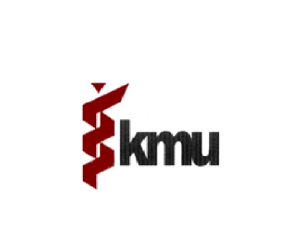 | Khyber Medical University  Committed to Excellence in Academic & Research
(Single stage Single envelop)
The Employer/ purchaser, Khyber Medical University, Peshawar invites sealed Bids based on MRS 2017 on percentage rates above/below/at par from contractors registered with Pakistan Engineering Council (PEC) in appropriate category, enlisted with works department who has renewed their registration for the year 2018-19 and also must required to be registered with Khyber Pakhtunkhwa Revenue Authority under the Khyber Pakhtunkhwa Finance Act, 2013 (KP Act No XXI of 2013) for works consulting and non consulting services as listed in schedule-II of the Act ibid. Details are as under.
S# | Name of work | Estimated Cost Rs. | Bid Security | Bid Submission date and Time | Date of Opening and Time
1 | Partition work of Aluminum at 06 rooms of IPH&SS Academic block and Library of KMU, Peshawar | 1824000/- | 2% of the bid cost | 19-12-2018 at 10:00 am | 19-12-2018 at 10:30 am
2 | Repair and maintenance of wash rooms at old IPM&R building KMU, Peshawar | 1035000/- | 2% of the bid cost | 19-12-2018 at 10:30 am | 19-12-2018 at 11:00 am

Terms and Conditions.
- A complete set of documents can be downloaded from KMU web site (www.kmu.edu.pk) or collect from the office of Deputy Director (Civil), KMU.
- Original Bid Security in the shape of call deposit in the name of Khyber Medical University shall accompany the bid.
- Bids will be dropped in tender box and will be opened in the office of Treasurer, KMU at given date & time by the purchase committee in the presence of the bidders or their representative.

Deputy Director (Civil) KMU, Peshawar))
0

O300-5876986

